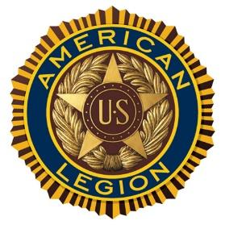

Norwich University Post #1819
American Legion

SCHOLARSHIP INFORMATION

The primary purpose of this program is to recognize deserving students by awarding scholarships for College education.

The American Legion Post 1819 will provide scholarships of $500. Applications will be accepted from candidates who are pursuing or about to pursue a college education.

- Applicant can be any student planning to attend or attending an accredited institution, college or university.
- Applicants should have graduated from High School or will have an equivalent certificate.
- Awards will not be made to individuals receiving full four year scholarships.
- Successful applicants may apply and qualify for scholarships on subsequent years. In no case will an applicant receive more than 4 scholarships unless enrolled in a recognized five year degree program.
The student must be attending school in the fall of the year awarded. (Students in the final semester prior to graduation or completion may not apply)
- The scholarship award will be given directly to the student upon receipt of proof of admission or registration at an accredited institution, college or university.
- A completed application must be received by the Post no later than February 21, 2018

Consideration for selection will include academic success in high school and college if already enrolled, extracurricular activities, community involvement and leadership positions held.

- Awarding of Scholarships will not be based primarily on financial status of the student or the student’s family.
- Priority will be given to Veterans who are members of post 1819
- Priority is given to Children of Veterans who are members of post 1819.
- Priority will be given to Veterans
- Priority is given to Students attending Norwich University and will be or are enrolled in the Corp of Cadets.
- Priority is given to Students attending Norwich University.

This list of priorities should be adhered to but the complete application must be taken into consideration for the awarding of any scholarship. The committee will have final decision for all scholarships awarded.

All scholarship applications must be received by 21 February 2018 via E-mail to post1819@legionpost1819.org

