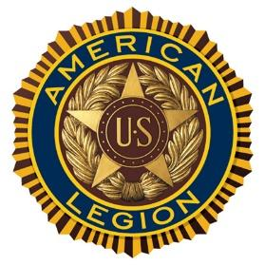

Norwich University Post #1819
American Legion

SCHOLARSHIP INFORMATION

The American Legion Post 1819 will recognizes deserving students by providing scholarships from $500 to $1,000 each for college education.

Applications will be accepted from candidates who are pursuing or about to pursue a college education and meet the following criteria:

- Applicant is an incoming freshman, sophomore, junior or senior student who is in a five year program and is planning to attend or is attending an accredited institution, college or university.
- Applicant will have graduated from High School or will have an equivalent certificate.
- Successful applicants may apply and qualify for scholarships on subsequent years. In no case will an applicant receive more than 4 scholarships unless enrolled in a recognized five year degree program. The student must be attending school in the fall of the year awarded. (Students in the final semester prior to graduation or completion may not apply).

The scholarship award will be given directly to the student in the spring of 2017 upon receipt of proof of admission or registration at an accredited institution, college, or university.

Note: Recipients of military or any other scholarship that pays 100% of the students cost of attending a university will be ineligible for any year covered by such a scholarship

Consideration for selection will include academic success in high school and college if already enrolled, extracurricular activities, community involvement and leadership positions held. Awarding of Scholarships will not be based primarily on financial status of the student or the student’s family. The following priorities will be used:

- Veterans who are members of Post 1819
- Children of veterans who are members of Post 1819.
- Veterans
- Students attending Norwich University and will be or are enrolled in the Corp of Cadets.
- Students attending Norwich University.

This list of priorities should be adhered to but the complete application will be taken into consideration for the awarding of any scholarship. The committee will have final decision for all scholarships awarded.

All scholarship applications must be received by 31 January 2017 via e-mail to: post1819@legionpost1819.org

